Pinouts
40 pin connector
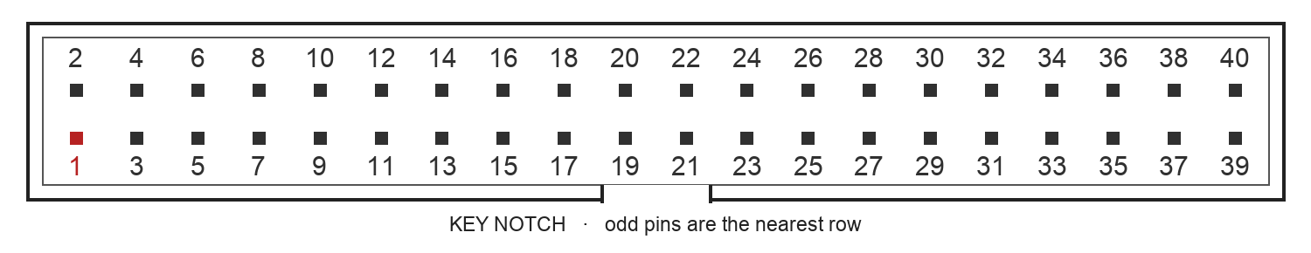
View from above the PCB into the header. Notch at bottom; pin 1 at bottom left.
Parts required on your board
40 pin contacts | Parts and placement
2, 4, 6, 8, 10, 12, 14, 26, 27 | One 33 Ω series resistor per line, close to the controlCARD.
28, 30, 31, 32, 34, 35, 36, 37 | One 10 kΩ pull-up per line to HSEC119 (3.3 V), close to the controlCARD.
16, 18, 20, 22, 24 | Each line: 330 pF C0G capacitor to ground, then 1.8 kΩ series resistor before the HSEC contact. Place near the socket.
Analog wiring order: 40 pin connector → capacitor node → 1.8 kΩ → HSEC. The capacitor connects from that node to ground. Do not add capacitors to PWM, ENABLE or relay commands.
ControlCARD power and ground contacts
5 V INPUT — Connect 5 V to HSEC 48, 84, 98, 112, 158 and 180.
GROUND — Connect HSEC 7, 10, 13, 16, 19, 22, 29, 35, 38, 46, 47, 65, 83, 97, 111, 135, 157 and 179 to the shared battery/control ground. Connect every 40 pin ground listed on page 2 to that same ground. Keep grid-side circuits isolated from it.
3.3 V OUTPUT — HSEC119 supplies the pull-ups above. Do not connect a separate 3.3 V regulator to this contact. All digital signals are 3.3 V; analog signals are 0–3.0 V.
40 pin connector to controlCARD
HSEC means the numbered socket contact. GPIO means the chip signal name. Route by the HSEC column. “To SEC” goes to the secondary; “To CTRL” comes back to the controller.
Ribbon | Signal | Meaning | HSEC | MCU connection
2 | PWM_AH | To SEC · leg A upper gate | 50 | GPIO0 / ePWM3A
4 | PWM_AL | To SEC · leg A lower gate | 125 | GPIO1 / ePWM3B
6 | PWM_BH | To SEC · leg B upper gate | 54 | GPIO2 / ePWM4A
8 | PWM_BL | To SEC · leg B lower gate | 56 | GPIO3 / ePWM4B
10 | PWM_CH | To SEC · leg C upper gate | 58 | GPIO12 / ePWM7A
12 | PWM_CL | To SEC · leg C lower gate | 60 | GPIO13 / ePWM7B
16 | V_BAT | To CTRL · secondary DC bus voltage | 28 | ADCC6
18 | I_BAT | To CTRL · battery current | 24 | ADCB4
20 | I_LEG_A | To CTRL · phase A current | 18 | ADCB2
22 | I_LEG_B | To CTRL · phase B current | 31 | ADCC2
24 | I_LEG_C | To CTRL · phase C current, drive only | 15 | ADCA2 · drive only
26 | RELAY_CMD | To SEC · high requests motor group closed | 73 | GPIO35
27 | RELAY_CMD | To SEC · high requests transformer group closed | 74 | GPIO23
34 | HALL_A | To CTRL · Hall A | 68 | GPIO20
35 | HALL_B | To CTRL · Hall B | 70 | GPIO21
36 | HALL_C | To CTRL · Hall C | 72 | GPIO22
37 | SEC_FAULT_N | To CTRL · low reports aggregate local fault | 85 | GPIO32
Ground | GND | 40 pin grounds: 1, 3, 5, 7, 9, 11, 13, 15, 17, 19, 21, 23, 25, 29, 33, 38 | GND | Shared ground; see page 1
39, 40 | SPARE | Leave unconnected at both ends | — | —

ControlCARD sockets and primary assignments
Main socket: Samtec HSEC8-160-01-L-DV-A-BL, 120 contacts.
Extension socket: Samtec HSEC8-130-01-L-DV-A, 60 contacts.
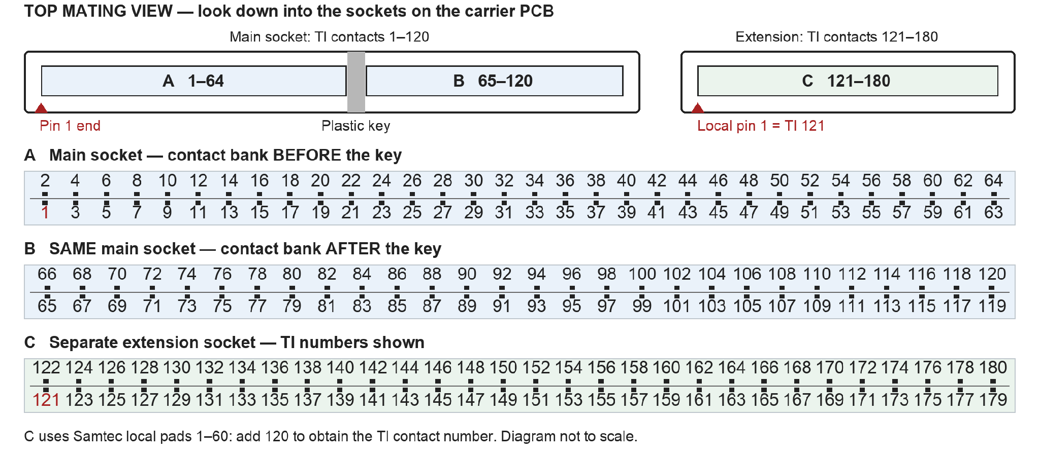
Top view into the carrier sockets. Extension pad 1 = HSEC121; add 120 to each extension pad number. Use TI’s docking-station layout for the socket spacing.
Primary signals to reserve
Primary signal | HSEC contacts | MCU connections
PWM_1 / A1; PWM_2 / A2 | 89 / 91 | GPIO40 / GPIO41 · CLB Output XBAR 1 / 2
PWM_3 / B1; PWM_4 / B2 | 162 / 163 | GPIO93 / GPIO94 · CLB Output XBAR 3 / 4
PWM_5 / C1; PWM_6 / C2 | 122 / 93 | GPIO36 / GPIO96 · CLB Output XBAR 5 / 6
PWM_7 / D1; PWM_8 / D2 | 92 / 95 | GPIO45 / GPIO98 · CLB Output XBAR 7 / 8
Enable | 77 | GPIO 25
Polarity | 79 | GPIO 26
Edge | 81 | GPIO 27
OUTP · ADC Header 3 | 9 | ADCA0
OUTN · ADC Header 2 | 11 | ADCA1
Shared battery ground · ADC Header 1 | 13 | GND
EPWM 1 (Master for CLB) | 49 / 51 | GPIO0 / GPIO1
EPWM 2 (ADC SOCA trigger) | 53 / 55 | GPIO2 / GPIO3
PWM_1–8 use CLB Output XBAR 1–8. Keep these outputs and their GPIOs for primary. Keep ePWM1, ePWM2 and ePWM7 for secondary. Contacts 62, 64, 67 and 69 remain proposed primary assignments; reserve them until confirmed.
TI routing sources: TMDSCNCD28P65X pinout · controlCARD schematic · controlCARD guide

